** MINISTRY OF EDUCATION AND TRAINING**

**FPT UNIVERSITY**

Capstone Project Document

The Traffic Sign Recognition and Training

|  |  |
| --- | --- |
| **Group 2** | |
| **Group member** | Mai Văn Tân – Team Leader – SE90061  Bùi Việt Phong – Team Member - SE60747  Hồ Đắc Nghĩa – Team Member - SE60628  Trần Lê Tuấn – Team Member - 60350 |
| **Supervisor** | Mr. Kiều Trọng Khánh |
| **Ext. Supervisor** | N/A |
| **Capstone Project code** | TSRT |

-Ho Chi Minh City, 01/2014-

*This page is intentionally left blank*

***ACKNOWLEDGEMENTS***

# Table of Contents

Table of Contents 4

List of Tables 5

List of Figures 6

Definitions, Acronyms, and Abbreviations 7

Report No.3 Software Requirement Specification 8

1. User Requirement Specification 8

1.1 Guest Requirement 8

1.2 Instructor Requirement 8

1.3 Staff Requirement 8

1.4 Student Requirement 8

1.5 Admin Requirement 8

1.6 System Requirement 8

2. System Requirement Specification 8

2.1 External Interface Requirement 8

2.2 System Overview Use Case 9

2.3 List of Use Case 10

3. Software System Attribute 51

3.1 Usability 51

3.2 Reliability 51

3.3 Availability 51

3.4 Security 51

3.5 Maintainability 51

3.6 Portability 51

3.7 Performance 51

4. ERD 52

# List of Tables

Table 1: <Guest> Register account 12

Table 2: <Guest> Login 13

Table 3: <Guest, User> Search manually using web application 15

Table 4: <Guest, User> Search manually using mobile application 16

Table 5: <Guest, User> Search auto using web application 18

Table 6: <Guest, User> Search auto using web application 20

Table 7: <User, Staff, Admin > Logout 22

Table 8: <User> Report traffic sign wrong information 23

Table 9: <User> Report traffic sign wrong recognize 25

Table 10: <User> Delete history using web application 26

Table 11: <User> Delete history using mobile application 27

Table 12: <User> Add favorite using web application 29

Table 13: <User> Add favorite using mobile application 30

Table 14: <User> Remove favorite using web application 31

Table 15: <User> Remove favorite using mobile application 32

Table 16: <Staff> Add traffic sign 35

Table 17: <Staff> Edit traffic sign 36

Table 18: <Staff> Export to file 38

Table 19: <Staff> Import from file 39

Table 20: <Staff> View report 41

Table 21: <Staff> Delete report 43

Table 22: <Staff, Admin> Active Account 45

Table 23: <Staff, Admin> Deactivate Account 46

Table 24: <Staff, Admin> Make statistic 47

Table 25: <Admin> Configure system 48

Table 26: <Admin> Create staff account 51

# List of Figures

Figure 1: System Overview Use Case 9

Figure 2: <Guest> Overview Use Case 10

Figure 3: <Guest> Register account 10

Figure 4: <Guest> Login 12

Figure 5: <Guest, User> Search manually 14

Figure 6: <Guest, User> Search auto 17

Figure 7: <User> User over view 21

Figure 8: <User, Staff, Admin> Logout 21

Figure 9: <User> Report traffic sign wrong information 22

Figure 10: <User> Report traffic sign wrong recognize 24

Figure 11: <User> Delete history 25

Figure 12: <User> Add favorite 28

Figure 13: <User> Remove favorite 30

Figure 14: <Staff> Staff overview 33

Figure 15: <Staff> Add traffic sign 33

Figure 16: <Staff> Edit traffic sign 35

Figure 17: <Staff> Export to file 37

Figure 18: <Staff> Import from file 38

Figure 19: <Staff>View report 40

Figure 20: <Staff> Delete report 41

Figure 21: <Staff, Admin> Active Account 43

Figure 22: <Staff, Admin> Deactivate Account 45

Figure 23: <Staff, Admin> Make statistic 47

Figure 24: <Admin> Admin overview 48

Figure 25: <Admin> Configure system 48

Figure 26: <Admin> Create staff account 49

Figure 27: ERD - Conceptual Diagram 52

# Definitions, Acronyms, and Abbreviations

# Report No.3 Software Requirement Specification

## User Requirement Specification

### Guest Requirement

Guest is a person who doesn’t have access to the system. To use system functions, guest must Login.

### Instructor Requirement

Instructor is teacher of the university. Instructor’s account is **created by admin**?.Instructor can use mobile app or website, that can do functions:

* Check Attendance
* Report Attendance Rate

### Staff Requirement

Staff is the employee of the university office. Staff’s account is created by admin. Staff can use website with these functions:

* Manage Subject: Add/ Edit/Active/ Inactive Subject
* Manage Class: Add/Edit /Active/ Inactive Class
* Manage Teacher: Add/Edit Teacher
* Manage Student: Add/Edit Student. Import Student List
* Manage Roll Call: Add/Edit Roll Call
* Report Attendance Rate: Report by Class, Block, Student. Export report

### Student Requirement

Student is the student of the university. Student’s account is created by admin. . Staff can use website with function:

* Check Present Rate

### Admin Requirement

Admin is the one who maintained and config the system. Admin can do functions:

* Manage Account: Create/Edit/Active/Inactive Account
* Manage Student Image: Add/Delete Student’s Image
* Config System

### System Requirement

System is also an actor, run in the background to keep the system working. System can do functions:

* Auto free storage space
* Face Detection
* Face Recognition: Recognition Student/Store Result
* Manage Roll Call: Auto Active/Inactive Roll Call

## System Requirement Specification

### External Interface Requirement

#### User Interface

* + - The interface of website is clear, do not annoy customer.
    - The interface of mobile app must be clear, compatibale with touch screen. The size of controls must be big enough to touch on smartphone.
    - The error, warning messages must be make clear, easy to understand. Error warning does not disturb customer.

#### Hardware Interface

* The system will use the standard hardware and data communications resources of a standard computer.

#### Software Interface

* Firefox Browser, Chromes with Resolution (1280*800) or bigger and support JavaScript and HTML5
* Smartphone with Android 4.1 or above. Screen size (70 x 120 mm) or bigger.

#### Communication Protocol

* Website using HTTP protocol for communication between the web browser and the web server.
* Mobile app using HTTP protocol for communicating between app and web service.

### System Overview Use Case

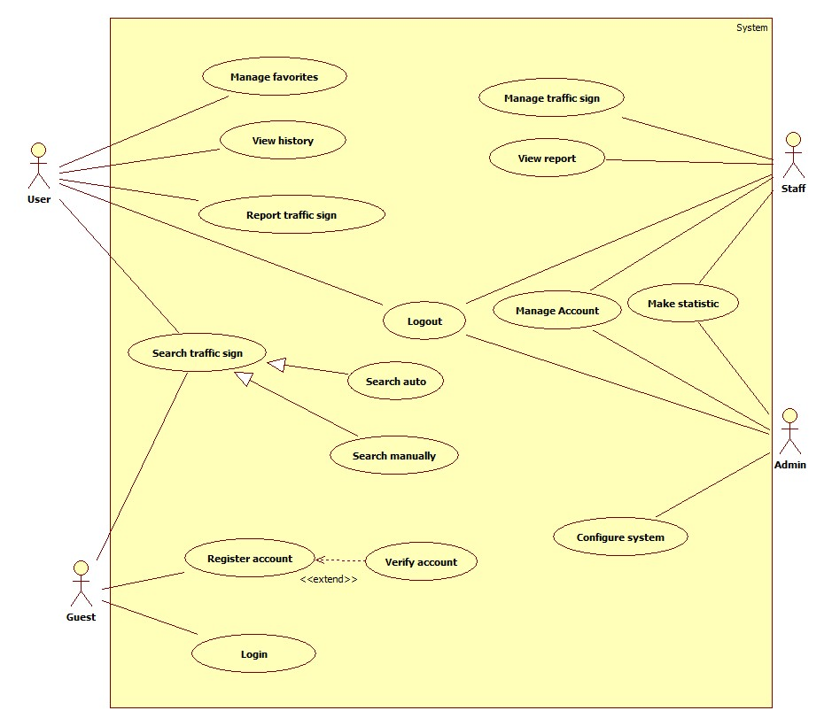

Figure 1: System Overview Use Case

### List of Use Case

#### <Guest>Overview Use Case

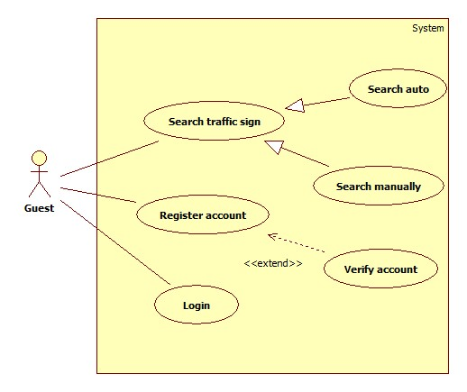

Figure 2: <Guest> Overview Use Case

##### <Guest>Register account

Use Case Diagram

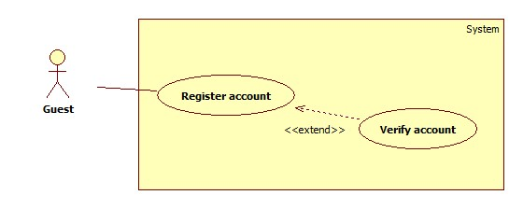

Figure 3: <Guest> Register account

Use Case Specification

|  |  |  |  |
| --- | --- | --- | --- |
| **USE CASE – GU001** | | | |
| **Use Case No.** | GU002 | **Use Case Version** | 1.0 |
| **Use Case Name** | Register | | |
| **Author** | Tran Le Tuan | | |
| **Date** | 15/01/2014 | **Priority** | Normal |
| **Actor:** Guest.  **Summary:**  Guest use this case to register account into system.  **Goal:**  Allow guest register account into system.  **Triggers:**   * Guest want to register account. * To register: Guest go to the register page, guest enter username, password, email, address then click on “Đăng ký” button to register.   **Preconditions:** N/A.  **Post Conditions:**   * **Success:** System will show success message on current page * **Fail:** System will show error message on current page   **Main Success Scenario:**   |  |  |  | | --- | --- | --- | | Step | Actor Action | System Response | | 1 | Guest click on “Đăng ký” button. | System redirect to register page, contain a register form:   * “Tên đăng nhập”: textbox (min length: 5, max length: 30, required). * “Mật khẩu”: textbox (password box, min length: 5, max length: 30, required). * “Nhập lại mật khẩu”: textbox (password box, min length: 5, max length: 30, required). * “Email”: textbox ( [abc@xyz.com](mailto:abc@xyz.com)) required. * “Đăng ký” button. | | 2 | Guest enter register information.  Press “Đăng ký” button. | System send verify email and show the success message: “Bạn đã đăng ký thành công, vui lòng xác nhận email để kích hoạt tài khoản”.  [Exception 1, 2, 3, 4, 5] | | 3 | Guest verify account | System show message “Chúc mừng bạn kích hoạt thành công” and redirect to homepage  [Exception 6] |   **Alternative Scenario:** N/A  **Exceptions:**   |  |  |  | | --- | --- | --- | | No | Actor Action | System Response | | 1 | Missing information. | Show error message: “Vui lòng nhập đầy đủ thông tin”. | | 2 | Username/Password not in range [5,30] | Show error message: “Tên đăng nhập và mật khẩu phải từ 5-30 ký tự”. | | 3 | Input invalid retype password. | Show error message: “Thông tin nhập vào không đúng”. | | 4 | Input invalid email. | Show error message: “Email không hợp lệ” | | 5 | Existed username/email | Show error message: “Tên đăng nhập hoặc email đã được sử dụng” | | 6 | Verify link is expired | Show error message: “Đã hết hạn kích hoạt. Liên lạc với admin để có thêm thông tin” |   **Relationships:** N/A  **Business Rules:**   * Each user can register an account. | | | |

Table 1: <Guest> Register account

##### <Guest>Login

Use Case Diagram

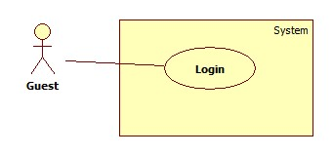

Figure 4: <Guest> Login

Use Case Specification

|  |  |  |  |
| --- | --- | --- | --- |
| **USE CASE – GU001** | | | |
| **Use Case No.** | GU001 | **Use Case Version** | 2.0 |
| **Use Case Name** | Login | | |
| **Author** | Tran Le Tuan | | |
| **Date** | 15/01/2014 | **Priority** | Normal |
| **Actor:** Guest.  **Summary:**  Guest use this case to login into system.  **Goal:**  Allow authentication and authorization of the system.  **Triggers:**   * Guest want to login into system. * To login: Guest go to the login page, guest enter username and password, then click on “Log in” button to login.   **Preconditions:** N/A.  **Post Conditions:**   * **Success:** Guest is authorized, redirect to corresponding page. * **Fail:** System will show error on current page   **Main Success Scenario:**   |  |  |  | | --- | --- | --- | | Step | Actor Action | System Response | | 1 | Guest click on “Đăng nhập” button. | System show a login form, includes:   * Tên đăng nhập: textbox (min length: 5, max length: 30, required). * Mật khẩu: textbox (password box, min length: 5, max length: 30, required). * Đăng nhập: button. | | 1 | Guess enter username and password into textboxs.  Press “Đăng nhập” button. | Guest is logged into system, authorized with corresponding role. Redirect to home page.  [Exception 1,2] |   **Alternative Scenario:** N/A  **Exceptions:**   |  |  |  | | --- | --- | --- | | No | Actor Action | System Response | | 1 | No input in “Tên đăng nhập” or “Mật khẩu” textboxs | Show error message: “Vui lòng nhập thông tin đăng nhập”. | | 2 | Username/Password not in range [5,30] | Show error message: “Tên đăng nhập/Mật khẩu phải từ 5-30 ký tự” textbox. | | 3 | Input invalid username or password | Show error message: “Tên đăng nhập hoặc mật khẩu không đúng”. |   **Relationships:** N/A  **Business Rules:**   * Each user, staff, admin has an account. * Only active account can log in. | | | |

Table 2: <Guest> Login

##### <Guest, User>Search manually

Use Case Diagram

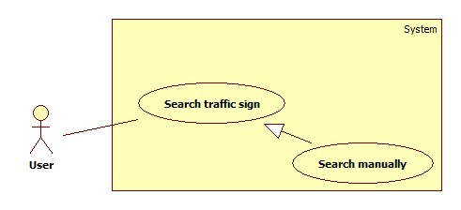

Figure 5: <Guest, User> Search manually

Use Case Specification

|  |  |  |  |
| --- | --- | --- | --- |
| **USE CASE –** | | | |
| **Use Case No.** |  | **Use Case Version** | 1.0 |
| **Use Case Name** | Search manually using web application | | |
| **Author** | Mai Van Tan | | |
| **Date** | 15/01/2014 | **Priority** | Normal |
| **Actor:** Guest, User  **Summary:**   * User use this case to search manually   **Goal:**   * Allow user to search a traffic sign   **Triggers:**   * User want to search traffic sign in manually * User can search manually by input a key work or view a list and choice the traffic sign. * User select “Tìm kiếm biển báo” in menu bar, input keyword in “Từ khóa” textbox then press “Tìm kiếm”. The system will return a list of traffic sign, select the traffic sign to view information.   **Preconditions:** N/A  **Post Conditions:**   * **Success**: System will show the information of the traffic sign * **Fail:** Show the error to user   **Main Success Scenario:**   |  |  |  | | --- | --- | --- | | Step | Actor Action | System Response | | 1 | User select “Tìm kiếm biển báo” in menu bar | System redirect to search traffic sign page, contain:   * Groupbox: “Tìm kiếm tự động” * Groupbox: “Tìm kiếm bằng tay”   + “Từ khóa”: textbox  + “Tìm kiếm”: button  + List of main type traffic sign | | 2 | User input keyword in “Từ khóa” and press “Tìm kiếm”  [Alternative 1] | System return a list of traffic sign match with the input keyword  [Exception 1] | | 3 | User select a traffic sign in list | System redirect to traffic sign information contain:  Tên biển báo: label  Hình ảnh: Image  Nội dung biển báo: label  Mức phạt: label |   **Alternative Scenario:**  **1.**   |  |  |  | | --- | --- | --- | | Step | Actor Action | System Response | | 1 | User select a type in list main traffic sign type | Show the list of traffic sign of type that user selected. | | 2 | User select a traffic sign in list | System redirect to traffic sign information contain:  Tên biển báo: label  Hình ảnh: Image  Nội dung biển báo: label  Mức phạt: label |   **Exceptions:**   |  |  |  | | --- | --- | --- | | No | Actor Action | System Response | | 1 | No result match with keyword | Show message: “Không tìm thấy” |   **Relationships: N/A**  **Business Rules: N/A** | | | |
|  | | | |

Table 3: <Guest, User> Search manually using web application

|  |  |  |  |
| --- | --- | --- | --- |
| **USE CASE –** | | | |
| **Use Case No.** |  | **Use Case Version** | 1.0 |
| **Use Case Name** | Search manually using mobile application | | |
| **Author** | Mai Van Tan | | |
| **Date** | 15/01/2014 | **Priority** | Normal |
| **Actor:** Guest, User  **Summary:**   * User use this case to search manually   **Goal:**   * Allow user to search a traffic sign   **Triggers:**   * User want to search traffic sign in manually * User can search manually by input a key work or view a list and choice the traffic sign. * User select search traffic sign in manually item [image], input keyword in “Từ khóa” textbox then press “Tìm kiếm”. The system will return a list of traffic sign, select the traffic sign to view information.   **Preconditions:** N/A  **Post Conditions:**   * **Success**: System will show the information of the traffic sign * **Fail:** Show the error to user   **Main Success Scenario:**   |  |  |  | | --- | --- | --- | | Step | Actor Action | System Response | | 1 | User select search traffic sign in manually item [image] | System redirect to search traffic in manually screen, contain:  + “Từ khóa”: textbox  + “Tìm kiếm”: button  + List of main type traffic sign | | 2 | User input keyword in “Từ khóa” and press “Tìm kiếm”  [Alternative 1] | System return a list of traffic sign match with the input keyword  [Exception 1] | | 3 | User select a traffic sign in list | System redirect to traffic sign information contain:  Tên biển báo: label  Hình ảnh: Image  Nội dung biển báo: label  Mức phạt: label |   **Alternative Scenario:**  **1.**   |  |  |  | | --- | --- | --- | | Step | Actor Action | System Response | | 1 | User select a type in list main traffic sign type | Show the list of traffic sign of type that user selected. | | 2 | User select a traffic sign in list | System redirect to traffic sign information contain:  Tên biển báo: label  Hình ảnh: Image  Nội dung biển báo: label  Mức phạt: label |   **Exceptions:**   |  |  |  | | --- | --- | --- | | No | Actor Action | System Response | | 1 | No result match with keyword | Show message: “Không tìm thấy” |   **Relationships: N/A**  **Business Rules: N/A** | | | |
|  | | | |

Table 4: <Guest, User> Search manually using mobile application

##### <Guest, User>Search auto

Use Case Diagram

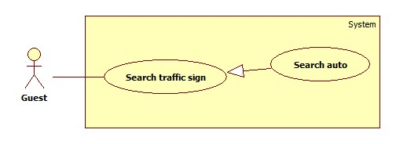

Figure 6: <Guest, User> Search auto

Use Case Specification

|  |  |  |  |
| --- | --- | --- | --- |
| **USE CASE –** | | | |
| **Use Case No.** |  | **Use Case Version** | 1.0 |
| **Use Case Name** | Search auto using web application | | |
| **Author** | Mai Van Tan | | |
| **Date** | 15/01/2014 | **Priority** | Normal |
| **Actor:** Guest, User  **Summary:**   * User use this case to auto search traffic sign   **Goal:**   * Allow user to search traffic sign automatically   **Triggers:**   * User want to search traffic sign automatically * User select “Tìm kiếm biển báo” in menu bar, select an image and press “Tải lên và tìm kiếm”, then system will return a list of result. User select a traffic sign to view information of it.   **Preconditions:**  **Post Conditions:**   * **Success**: System will show the information of the traffic sign * **Fail:** Show the error to user.   **Main Success Scenario:**   |  |  |  | | --- | --- | --- | | Step | Actor Action | System Response | | 1 | User click on “Tìm kiếm biển báo” in menu bar | System redirect to search traffic sign page, contain:   * Groupbox: “Tìm kiếm tự động”   + File picker:  + “Tải lên và tìm kiếm”: button   * Groupbox: “Tìm kiếm bằng tay”   + “Từ khóa”: textbox  + “Tìm kiếm”: button  + List of main type traffic sign | | 2 | User select an image and press “Tải lên và tìm kiếm” | System receive the image, process. After done, redirect to result page contain:   * Image uploaded * List of traffic sign recognized   [Exception 1] | | 3 | User select an traffic sign to view detail | System redirect to view traffic sign information page, contain:  Tên biển báo: label  Hình ảnh: Image  Nội dung biển báo: label  Mức phạt: label |   **Alternative Scenario:** N/A  **Exceptions:**   |  |  |  | | --- | --- | --- | | No | Actor Action | System Response | | 1 | No result match with keyword | Show message: “Không tìm thấy” |   **Relationships: N/A**  **Business Rules: N/A** | | | |
|  | | | |

Table 5: <Guest, User> Search auto using web application

|  |  |  |  |
| --- | --- | --- | --- |
| **USE CASE –** | | | |
| **Use Case No.** |  | **Use Case Version** | 1.0 |
| **Use Case Name** | Search auto using mobile application | | |
| **Author** | Mai Van Tan | | |
| **Date** | 15/01/2014 | **Priority** | Normal |
| **Actor:** Guest, User  **Summary:**   * User use this case to auto search traffic sign in mobile   **Goal:**   * Allow user to search traffic sign automatically   **Triggers:**   * User want to search traffic sign automatically * User select search auto item [image], system open a camera screen. User take a photo and submit to server, then system will return a list of result. User select a traffic sign to view information of it.   **Preconditions:**  **Post Conditions:**   * **Success**: System will show the information of the traffic sign * **Fail:** Show the error to user.   **Main Success Scenario:**   |  |  |  | | --- | --- | --- | | Step | Actor Action | System Response | | 1 | User select search auto item [image] | System show the screen contain:   * Chụp ảnh biển bao: label * Chọn ảnh có sẵn: label | | 2 | User select “Chụp ảnh biển báo” | System will open camera screen,   * Preview image screen * Button [image]: take and submit the image | | 3 | User take a photo and submit to the server  [Alternative 1][Alternative 2] | System receive the photo, after process system redirect to result page contain a list of traffic sign  [Exception 1] | | 4 | User select a traffic sign to view information | System redirect to traffic sign information page contain:  Tên biển báo: label  Hình ảnh: Image  Nội dung biển báo: label  Mức phạt: label |   **Alternative Scenario:**  **1.**   |  |  |  | | --- | --- | --- | | Step | Actor Action | System Response | | 1 | User select “Chọn ảnh có sẳn” and select an image  [Alternative 2] | System receive the photo, after process system redirect to result page contain a list of traffic sign  [Exception 1] | | 2 | User select a traffic sign to view information | System redirect to traffic sign information page contain:  Tên biển báo: label  Hình ảnh: Image  Nội dung biển báo: label  Mức phạt: label |   **2.**   |  |  |  | | --- | --- | --- | | Step | Actor Action | System Response | | 1 | No internet connection | Show message: “Không có kết nối internet, chương trình sẽ tự động tìm kiếm khi có internet” | | 2 | When internet available | System receive the photo, after process system notify user | | 3 | User view the notification | System show the list result  [Exception 1] | | 4 | User select a traffic sign to view information | System redirect to traffic sign information screen contain:  Tên biển báo: label  Hình ảnh: Image  Nội dung biển báo: label  Mức phạt: label |   **Exceptions:**   |  |  |  | | --- | --- | --- | | No | Actor Action | System Response | | 1 | No result match with keyword | Show message: “Không tìm thấy” |   **Relationships: N/A**  **Business Rules: N/A** | | | |

Table 6: <Guest, User> Search auto using web application

#### <User> User over view

Use Case Diagram

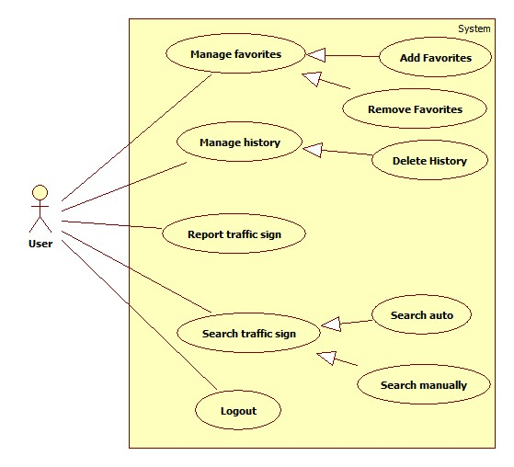

Figure 7: <User> User over view

##### <User, Staff, Admin> Logout

Use Case Diagram

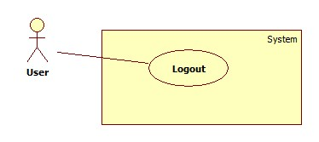

Figure 8: <User, Staff, Admin> Logout

Use Case Specification

|  |  |  |  |
| --- | --- | --- | --- |
| **USE CASE – UU001** | | | |
| **Use Case No.** | UU001 | **Use Case Version** | 1.0 |
| **Use Case Name** |  | | |
| **Author** |  | | |
| **Date** | 15/01/2014 | **Priority** | Normal |
| **Actor:** User  **Summary:**  User use this case to logout  **Goal:**  Allow user to logout  **Triggers:**  User want to logout  User click on “Thoát” button  **Preconditions:**   * User must logged in the system with the role is user.   **Post Conditions:**  **Success:** User logout and redirect to home  **Fail:**  **Main Success Scenario:**   |  |  |  | | --- | --- | --- | | Step | Actor Action | System Response | | 1 | User click on “Thoát” button | System delete user session and redirect to home page |   **Alternative Scenario:** N/A  **Exceptions:** N/A  **Relationships:** N/A  **Business Rules:** N/A | | | |

Table 7: <User, Staff, Admin > Logout

##### <User> Report traffic sign wrong information

Use Case Diagram

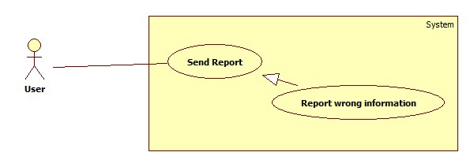

Figure 9: <User> Report traffic sign wrong information

Use Case Specification

|  |  |  |  |
| --- | --- | --- | --- |
| **USE CASE – UU002** | | | |
| **Use Case No.** | UU002 | **Use Case Version** | 1.0 |
| **Use Case Name** | Report wrong information | | |
| **Author** | Ho Dac Nghia | | |
| **Date** | 15/01/2014 | **Priority** | Normal |
| **Actor:** User  **Summary:**  User use this case to report traffic sign.  **Goal:**  Allow user to report traffic sign  **Triggers:**   * User want to report wrong traffic sign(wrong information) * When user view search result and think that result is wrong then user can click on report item on traffic sign information page.   **Preconditions:**   * User must logged in the system.   **Post Conditions:**  **Success:** The report of a traffic sign will be save on server  **Fail:** No report send.  **Main Success Scenario:**   |  |  |  | | --- | --- | --- | | Step | Actor Action | System Response | | 1 | While view search result, user click on the report item | System redirect to report page: - Textbox: “Nội dung phản hồi” - Button: “Hủy” - Button: “Gửi” | | 2 | User input report content and click on “Gửi” button  [Alternative 1] | System send report to server and show message “Cám ơn bạn đã gửi phản hồi” and go back to result page |   **Alternative Scenario:**   |  |  |  | | --- | --- | --- | | No | Actor Action | System Response | | 1 | User click on “Hủy” button | System back to result page |   **Exceptions:** N/A  **Relationships:** N/A  **Business Rules:** N/A | | | |

Table 8: <User> Report traffic sign wrong information

##### <User> Report traffic sign wrong recognize

Use Case Diagram

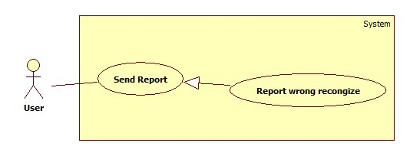

Figure 10: <User> Report traffic sign wrong recognize

Use Case Specification

|  |  |  |  |
| --- | --- | --- | --- |
| **USE CASE – UU002** | | | |
| **Use Case No.** | UU002 | **Use Case Version** | 1.0 |
| **Use Case Name** | Report Wrong Recognize | | |
| **Author** | Ho Dac Nghia | | |
| **Date** | 15/01/2014 | **Priority** | Normal |
| **Actor:** User  **Summary:**  User use this case to report traffic sign recognize.  **Goal:**  Allow user to report traffic sign recognize.  **Triggers:**   * User want to report wrong traffic sign(wrong recognize traffic sign) * When user want to recognize a traffic sign but the system can’t show the result of that traffic sign. * User can click report item on auto search result page .   **Preconditions:**  User must logged in the system with the role is user.  **Post Conditions:**  **Success:** The report of a traffic sign will be save on server  **Fail:** No report send.  **Main Success Scenario:**   |  |  |  | | --- | --- | --- | | Step | Actor Action | System Response | | 1 | In the recognize page, user can click “Phản hồi” item. | System redirect to report page: - Textbox: “Nội dung phản hồi” - Button: “Hủy” - Button: “Gửi” | | 2 | User input report content and click on “Gửi” button  [Alternative 1] | System send report to server and show message “Cám ơn bạn đã gửi phản hồi” and go back to result page |   **Alternative Scenario:**   |  |  |  | | --- | --- | --- | | No | Actor Action | System Response | | 1 | User click on “Hủy” button | System back to result page | | | | |
| **Exception:** N/A  **Relationships:** N/A  **Business Rules:** N/A | | | |

Table 9: <User> Report traffic sign wrong recognize

##### <User> Delete history

Use Case Diagram

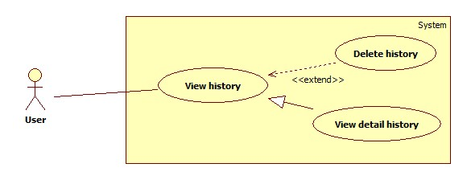

Figure 11: <User> Delete history

Use Case Specification

|  |  |  |  |
| --- | --- | --- | --- |
| **USE CASE –** | | | |
| **Use Case No.** |  | **Use Case Version** | 1.0 |
| **Use Case Name** | Delete history using web application | | |
| **Author** | Mai Van Tan | | |
| **Date** | 15/01/2014 | **Priority** | Normal |
| **Actor:** User  **Summary:**   * User use this case to delete search history in web application   **Goal:**   * Allow user delete their search history.   **Triggers:**   * User want to delete history of search result * User view list of history or view history detail then select “Xóa” button. Confirm to delete by press “Đồng ý”.   **Preconditions:**   * User must login.   **Post Conditions:**   * **Success**: The history will be deleted from system * **Fail:** Show the error to user.   **Main Success Scenario:**   |  |  |  | | --- | --- | --- | | Step | Actor Action | System Response | | 1 | User select “Xem lịch sử tìm kiếm” | System redirect to history page contain a list of search history   * List of search history * Button: “Xóa” on each row | | 2 | User select “Xóa” button  [Alternative 1] | System show message: “Bạn có chắc chắn muốn xóa?” | | 3 | User select “Đồng ý” | System delete the history and refresh the list  [Exception 1] |   **Alternative Scenario:**   |  |  |  | | --- | --- | --- | | No | Actor Action | System Response | | 1 | User select to view history detail | System redirect to view history detail page, like result page when make search auto [reference to]   * Button: “Xóa” | | 2 | User select “Xóa” button | System show message: “Bạn có chắc chắn muốn xóa?” | | 3 | User select “Đồng ý” | System delete the history and refresh the list  [Exception 1] |   **Exceptions:**   |  |  |  | | --- | --- | --- | | No | Actor Action | System Response | | 1 | Cannot delete history. | Show message: “Xóa không thành công”. |   **Relationships: Search auto in web application usecase**  **Business Rules: N/A** | | | |

Table 10: <User> Delete history using web application

|  |  |  |  |
| --- | --- | --- | --- |
| **USE CASE –** | | | |
| **Use Case No.** |  | **Use Case Version** | 1.0 |
| **Use Case Name** | Delete history using mobile application | | |
| **Author** | Mai Van Tan | | |
| **Date** | 15/01/2014 | **Priority** | Normal |
| **Actor:** User  **Summary:**   * User use this case to delete search history in mobile application   **Goal:**   * Allow user deletes their search history.   **Triggers:**   * User want to delete history of search result * User view list of history or view history detail then select “Xóa” button. Confirm to delete by press “Đồng ý”.   **Preconditions:**   * User must login.   **Post Conditions:**   * **Success**: The history will be deleted from system * **Fail:** Show the error to user.   **Main Success Scenario:**   |  |  |  | | --- | --- | --- | | Step | Actor Action | System Response | | 1 | User select “Xem lịch sử tìm kiếm” | System redirect to history screen contain a list of search history   * List of search history | | 2 | User press and hold for 1s in a history item, then select “Xóa”  [Alternative 1] | System show message: “Bạn có chắc chắn muốn xóa?” | | 3 | User select “Đồng ý” | System delete the history and refresh the list  [Exception 1] |   **Alternative Scenario:**   |  |  |  | | --- | --- | --- | | Step | Actor Action | System Response | | 1 | User select to view history detail | System redirect to view history detail screen, like result screen when make search auto [reference to]   * Button: “Xóa” | | 2 | User select “Xóa” button | System show message: “Bạn có chắc chắn muốn xóa?” | | 3 | User select “Đồng ý” | System delete the history and refresh the list  [Exception 1] |   **Exceptions:**   |  |  |  | | --- | --- | --- | | No | Actor Action | System Response | | 1 | Cannot delete history. | Show message: “Xóa không thành công”. |   **Relationships: Search auto in mobile application usecase**  **Business Rules: N/A** | | | |

Table 11: <User> Delete history using mobile application

##### <User> Add favorite

Use Case Diagram

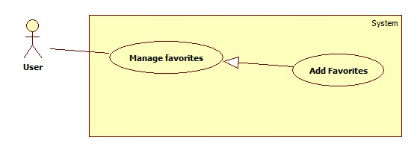

Figure 12: <User> Add favorite

Use Case Specification

|  |  |  |  |
| --- | --- | --- | --- |
| **USE CASE – UU004** | | | |
| **Use Case No.** | UU004 | **Use Case Version** | 1.0 |
| **Use Case Name** | Add favorite (Using web application) | | |
| **Author** | Bui Viet Phong | | |
| **Date** | 15/01/2014 | **Priority** | Normal |
| **Actor:** User  **Summary:**  This user case allow user to add a traffic sign into favorite list.  **Goal:**  Add a traffic sign into favorite list.  **Triggers:**   * In our system, each user has a favorite list to bookmark traffic signs for viewing later again. * To add a traffic sign into favorite list, user must: * View traffic sign details by auto search or manually search. * On the traffic sign details screen, click button “Thêm vào danh sách yêu thích”.   **Preconditions:**   * Guest must log in the system. * The traffic sign is not added into favorite list before.   **Post Conditions:**   * **Success:** The popup inform that the traffic sign has been added to favorite list * **Fail:** No traffic sign has been added to favorite list.   **Main Success Scenario:**   |  |  |  | | --- | --- | --- | | Step | Actor Action | System Response | | 1 | - Click one type off traffic sign in category  [Alternative 1] [Alternative 2] | Show the list of traffic signs in the category which was chosen by user. | | 2 | Click on one traffic sign in the list.  [Alternative 2] | Show the Traffic details screen, contains detail of traffic sign, include:   * Traffic sign Image * Traffic sign content * Penalize fee. | | 3 | Click button “Thêm vào danh sách yêu thích” | Add the traffic sign to favorite list and show the notice with message:  “Biển báo đã được thêm vào danh sách yêu thích” |   **Alternative Scenario:**   |  |  |  | | --- | --- | --- | | No | Actor Action | System Response | | 1 | Enter traffic sign’s name then click “Tìm kiếm” | Show the list of traffic signs have name match with key words. | | 2 | View a traffic sign by search auto on web in use case **ABC** |  |   **Exceptions:** N/A  **Relationships:** Manage favorite  **Business Rules:** N/A | | | |

Table 12: <User> Add favorite using web application

|  |  |  |  |
| --- | --- | --- | --- |
| **USE CASE – UU004** | | | |
| **Use Case No.** | UU004 | **Use Case Version** | 1.0 |
| **Use Case Name** | Add to favorite (Using mobile application) | | |
| **Author** | Bui Viet Phong | | |
| **Date** | 15/01/2014 | **Priority** | Normal |
| **Actor:** User  **Summary:**  This user case allow user to add a traffic sign into favorite list.  **Goal:**  Add a traffic sign into favorite list.  **Triggers:**   * In our system, each user has a favorite list to bookmark traffic signs for viewing later again. * To add a traffic sign into favorite list, user must: * View traffic sign details by auto search or manually search. * On the traffic sign details screen, select favorite item.   **Preconditions:**   * Guest must log in the system. * The traffic sign is not added into favorite list before.   **Post Conditions:**   * **Success:** The popup inform that the traffic sign has been added to favorite list * **Fail:** No traffic sign has been added to favorite list.   **Main Success Scenario:**   |  |  |  | | --- | --- | --- | | Step | Actor Action | System Response | | 1 | - Choose ‘Tra cứu biển báo’  - Choose one item in category.  [Alternative 1] | Show the list of traffic signs in the category which was chosen by user before. | | 2 | Choose one traffic sign in the list.  [Alternative 1] | Show the Traffic details screen, contains detail of traffic sign, include:   * Traffic sign Image * Traffic sign content * Penalize fee. | | 3 | Click on favorite item at the top-right corner of the screen. | Add the traffic sign to favorite list and show the message:  “Biển báo đã được thêm vào danh sách yêu thích” |   **Alternative Scenario:**   |  |  |  | | --- | --- | --- | | No | Actor Action | System Response | | 1 | [Alternative 1]  View a traffic sign by search auto on mobile in use case **ABC** |  |   **Exceptions:** N/A  **Relationships:** Manage favorite  **Business Rules:** N/A | | | |

Table 13: <User> Add favorite using mobile application

##### <User> Remove favorite

Use Case Diagram

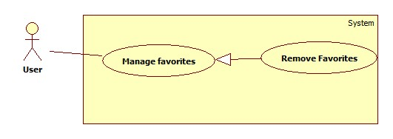

Figure 13: <User> Remove favorite

Use Case Specification

|  |  |  |  |
| --- | --- | --- | --- |
| **USE CASE – UU005** | | | |
| **Use Case No.** | UU005 | **Use Case Version** | 1.0 |
| **Use Case Name** | Remove favorite (Using web application) | | |
| **Author** | Bui Viet Phong | | |
| **Date** | 15/01/2014 | **Priority** | Normal |
| **Actor:** User  **Summary:**  This user case allow user to remove a traffic sign from favorite list.  **Goal:**  Remove a traffic sign from favorite list**.**  **Triggers:**   * In our system, each user has a favorite list to bookmark traffic signs for viewing later again. * To remove a traffic sign from favorite list, user must: * Select ‘Danh sách yêu thích’ to view favorite list. * Select ‘Xóa’.   **Preconditions:**   * Guest must logged in the system.   **Post Conditions:**   * **Success:** The traffic sign has been remove from favorite list. * **Fail:** No traffic signs has been remove from favorite list.   **Main Success Scenario:**   |  |  |  | | --- | --- | --- | | Step | Actor Action | System Response | | 1 | - Click ‘Danh sách yêu thích’ | Redirect to favorite page, include:   * List of traffic signs in the favorite list. * Button “Xóa” | | 2 | Click button “Xóa” in the row contain the traffic | Remove the traffic sign from favorite list. |   **Alternative Scenario:** N/A  **Exceptions:** N/A  **Relationships:** Manage favorite  **Business Rules:** N/A | | | |

Table 14: <User> Remove favorite using web application

|  |  |  |  |
| --- | --- | --- | --- |
| **USE CASE – UU005** | | | |
| **Use Case No.** | UU005 | **Use Case Version** | 1.0 |
| **Use Case Name** | Remove favorite (Using mobile application) | | |
| **Author** | Bui Viet Phong | | |
| **Date** | 15/01/2014 | **Priority** | Normal |
| **Actor:** User  **Summary:**  This user case allow user to remove a traffic sign from favorite list.  **Goal:**  Remove a traffic sign from favorite list**.**  **Triggers:**   * In our system, each user has a favorite list to bookmark traffic signs for viewing later again. * To remove a traffic sign from favorite list, user must: * Select ‘Danh sách yêu thích’ to view favorite list. * Select and hold on the traffic sign for 1 second. * Select ‘Xóa’.   **Preconditions:**   * Guest must logged in the system.   **Post Conditions:**   * **Success:** The traffic sign has been remove from favorite list. * **Fail:** No traffic signs has been remove from favorite list.   **Main Success Scenario:**   |  |  |  | | --- | --- | --- | | Step | Actor Action | System Response | | 1 | - Click ‘Danh sách yêu thích’  [Alternative 1] | Show the list of traffic signs in the favorite list. | | 2 | Select and hold on one traffic sign in the list for 1 second.  [Alternative 1] | Show the menu, contains below items:   * Chuyển lên trên * Chuyển xuống dưới * Xóa | | 3 | Select ‘Xóa’  [Alternative 1] | Remove the traffic sign from favorite list. |   **Alternative 1:**   |  |  |  | | --- | --- | --- | | Step | Actor Action | System Response | | 1 | - View a traffic sign by search auto or by search manually on mobile in use case **ABC** – |  | | 2 | Select the “Yellow star” on the top-right screen | Remove the traffic sign from favorite list. |   **Exceptions:** N/A  **Relationships:** Manage favorite  **Business Rules:** N/A | | | |

Table 15: <User> Remove favorite using mobile application

#### <Staff> Staff overview

Use Case Diagram

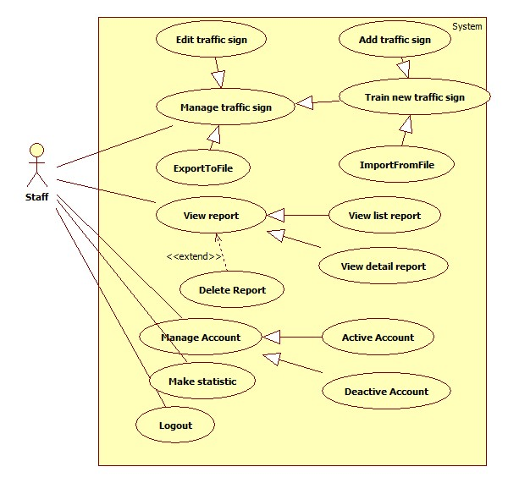

Figure 14: <Staff> Staff overview

##### <Staff> Add Traffic sign

Use Case Diagram

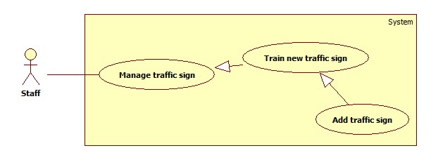

Figure 15: <Staff> Add traffic sign

Use Case Specification

|  |  |  |  |
| --- | --- | --- | --- |
| **USE CASE** | | | |
| **Use Case No.** | AD003 | **Use Case Version** | 2.0 |
| **Use Case Name** | Add traffic sign | | |
| **Author** | Tran Le Tuan | | |
| **Date** | 15/01/2014 | **Priority** | Normal |
| **Actor:** Staff  **Summary:**  Staff use this case to add new traffic sign  **Goal:**  New traffic sign will be added into database.  **Triggers:**   * We want to add a new traffic sign into database. * To add new sign, staff must: * From the staff Home Page, click the menu item “Quản lí”. * Select “Thêm biển báo” button.   **Preconditions:**   * Staff must login.   **Post Conditions:**   * **Success:** The selected sign(s) will be added. * **Fail:** No sign added. Transfer to error page.   **Main Success Scenario:**   |  |  |  | | --- | --- | --- | | Step | Actor Action | System Response | | 1 | Click menu item “Quản lí biển báo”. | Redirect to Sign Manager Page, includes a panel with 2 tabs:   * Danh sách biển báo. * Thêm biển báo.   Current tab is Account List. This tab includes:   * Table with 2 column: * Hình: label * Thông tin: label * Thêm: button * Hủy: button | | 2 | Fill information of the sign and press “Thêm” button.  [Alternative 1] | The new sign(s) will be added. System show message “Đã Thêm Biển Báo Thành Công”. |   **Alternative Scenario:**   |  |  |  | | --- | --- | --- | | No | Actor Action | System Response | | 1 | Click on “hủy” button | The form is emptied. |   **Exceptions:**   |  |  |  | | --- | --- | --- | | No | Actor Action | System Response | | 1 | Not enter enough require information. | Display error message: “Thông tin khai báo chưa đầy đủ.” | | 2 | Traffic sign name existed in database | Display error message:  “Biển báo đã tồn tại.” |   **Relationships:** Manage Account  **Business Rules:** | | | |

Table 16: <Staff> Add traffic sign

##### <Staff> Edit traffic sign

Use Case Diagram

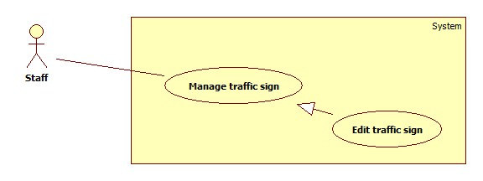

Figure 16: <Staff> Edit traffic sign

Use Case Specification

|  |  |  |  |
| --- | --- | --- | --- |
| **USE CASE – AD007** | | | |
| **Use Case No.** | AD007 | **Use Case Version** | 1.0 |
| **Use Case Name** | Edit traffic sign | | |
| **Author** | Bui Viet Phong | | |
| **Date** | 15/01/2014 | **Priority** | Normal |
| **Actor:** Staff  **Summary:**  This user case allow staff to edit traffic sign information or traffic images.  **Goal:**  Edit traffic sign information or traffic images**.**  **Triggers:**   * For recognize or view traffic signs details, the system must store traffic signs information and images for recognition. * To edit traffic signs, staff must: * Select ‘Quản lý biển báo’ * Click “Chỉnh sửa” * Edit information or add image then click “Hoàn tất”.   **Preconditions:**   * Guest must logged in the system with role staff.   **Post Conditions:**   * **Success:** The new traffic sign’s information or image will be updated. * **Fail: T**raffic sign’s information or image will not be updated.   **Main Success Scenario:**   |  |  |  | | --- | --- | --- | | Step | Actor Action | System Response | | 1 | - Click ‘Quản lý biển báo’ | Redirect to Traffic management page, contains:   * List of the current traffic signs. * “Tạo mới biển báo” button. * “Thêm biển báo từ tập tin” button * “Chỉnh sửa” button | | 2 | Click “Chỉnh sửa” button | Redirect to edit traffic sign page, contains:   * Text filed: All about traffic sign information. * File Upload Control. * “Hoàn tất” button. * “Hủy” button | | 3 | Edit information in text box or select file to upload from File Upload Control to add more image then click “Hoàn tất”.  [Alternative 1]  [Exception 1] | Update traffic sign information or images.  Redirect to Traffic management page. |   **Alternative Scenario:**   |  |  |  | | --- | --- | --- | | No | Actor Action | System Response | | 1 | [Alternative 1]  - Click “Hủy” button | Redirect to Traffic management page. |   **Exceptions:**   |  |  |  | | --- | --- | --- | | No | Actor Action | System Response | | 1 | Select wrong file. | Display error message: “ Tập tin không đúng định dạng” |   **Relationships:** Manage traffic signs  **Business Rules:** N/A | | | |

Table 17: <Staff> Edit traffic sign

##### <Staff> Export to file

Use Case Diagram

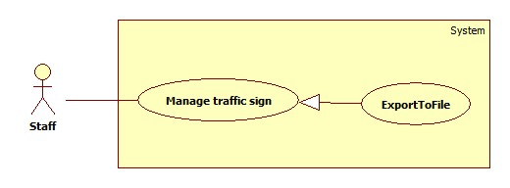

Figure 17: <Staff> Export to file

Use Case Specification

|  |  |  |  |
| --- | --- | --- | --- |
| **USE CASE – SU018** | | | |
| **Use Case No.** | SU018 | **Use Case Version** | 2.0 |
| **Use Case Name** | Export To File. | | |
| **Author** | Tran Le Tuan | | |
| **Date** | 15/01/2014 | **Priority** | Normal |
| **Actor:** Staff.  **Summary:**  Staff uses this case to export to file.  **Goal:**  Allow staff to export to file.  **Triggers:**   * Staff want to export to file. * To export file, we must :   + Staff login system  + On manage traffic sign page, click on button “Xuất tập tin” to export.  **Preconditions:**   * Staff must login.   **Post Conditions:**   * **Success**: Staff can export to file. * **Fail:** N/A.   **Main Success Scenario:**   |  |  |  | | --- | --- | --- | | Step | Actor Action | System Response | | 1 | Click on “Xuất tập tin” to request export on “quản lí” page | System will export report to file excel.  Show message “Xuất tập tin thành công”. |   **Alternative Scenario:** N/A  **Exceptions:** N/A  **Relationships: N/A**  **Business Rules: N/A** | | | |

Table 18: <Staff> Export to file

##### <Staff> Import from file

Use Case Diagram

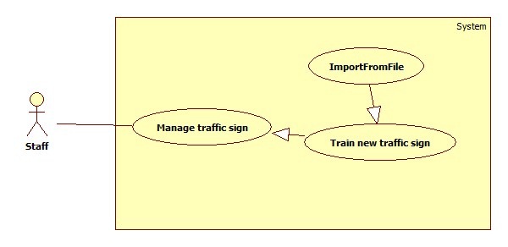

Figure 18: <Staff> Import from file

Use Case Specification

|  |  |  |  |
| --- | --- | --- | --- |
| **USE CASE – AD007** | | | |
| **Use Case No.** | AD007 | **Use Case Version** | 1.0 |
| **Use Case Name** | Import traffic sign from file | | |
| **Author** | Bui Viet Phong | | |
| **Date** | 15/01/2014 | **Priority** | Normal |
| **Actor:** Staff  **Summary:**  This user case allow staff to train new traffic signs from existing file.  **Goal:**  Train new traffic signs from existing file**.**  **Triggers:**   * For recognize or view traffic signs details, the system must store traffic signs information and images for recognition. * To train new traffic signs from existing file, staff must: * Select ‘Quản lý biển báo’ * Click “Thêm biển báo từ tập tin” * Select file to upload then click “Tải lên”.   **Preconditions:**   * Guest must logged in the system with role staff. * Staff has the file to upload.   **Post Conditions:**   * **Success:** The new traffic signs has been added to database. * **Fail:** No traffic signs has been has been added to database.   **Main Success Scenario:**   |  |  |  | | --- | --- | --- | | Step | Actor Action | System Response | | 1 | - Click ‘Quản lý biển báo’ | Redirect to Traffic management page, contains:   * List of the current traffic signs. * “Tạo mới biển báo” button. * “Thêm biển báo từ tập tin” button * “Chỉnh sửa” button | | 2 | Click “Thêm biển báo từ tập tin” button | Redirect to Import traffic sign page, contains:   * File Upload Control. * “Tải lên” button. * “Hủy” button | | 3 | Select file to upload from File Upload Control then click “Tải lên” button.  [Alternative 1]  [Exception 1]  [Exception 2] | Upload file and add new traffic signs to database.  Redirect to Traffic management page. |   **Alternative Scenario:**   |  |  |  | | --- | --- | --- | | No | Actor Action | System Response | | 1 | [Alternative 1]  - Click “Hủy” button | Redirect to Traffic management page. |   **Exceptions:**   |  |  |  | | --- | --- | --- | | No | Actor Action | System Response | | 1 | Not select file, click “Tải lên” button | Display error message: “Vui lòng chọn file để tải lên” | | 2 | Upload wrong file. | Display error message: “ Tập tin không đúng định dạng” |   **Relationships:** Manage traffic signs  **Business Rules:** N/A | | | |

Table 19: <Staff> Import from file

##### <Staff> View report

Use Case Diagram

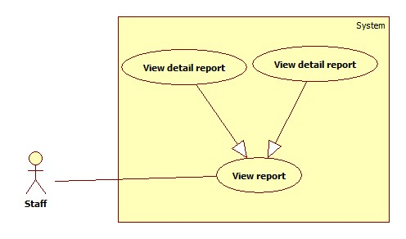

Figure 19: <Staff>View report

Use Case Specification

|  |  |  |  |
| --- | --- | --- | --- |
| **USE CASE – SU001** | | | |
| **Use Case No.** | SU001 | **Use Case Version** | 1.0 |
| **Use Case Name** | View Report | | |
| **Author** | Ho Dac Nghia | | |
| **Date** | 15/01/2014 | **Priority** | Normal |
| **Actor:** Staff  **Summary:**  Staff use this case to view report  **Goal:**   * Allow staff to view list of report or detail of report.   **Triggers:**   * Click menu item “Quản lý phản hồi” * System redirect to Report Page * The list of report will show * Click “Chi tiết” link to view details of report   **Preconditions:**   * Staff must login system.   **Post Conditions:**   * **Success:** The list of report will show.  Staff can view details of report. * **Fail:** No report list displayed   Staff can’t view details of report.  **Main Success Scenario:**   |  |  |  | | --- | --- | --- | | Step | Actor Action | System Response | | 1 | Click menu item“Quản lí phản hồi” | System redirect to Report page The list of report will show | | 2 | Staff click “Chi tiết” link | System redirect Report Details Page  The details of report will show |   **Exception**: N/A  **Relationships:** N/A  **Business Rules:** N/A | | | |

Table 20: <Staff> View report

##### <Staff> Delete report

Use Case Diagram

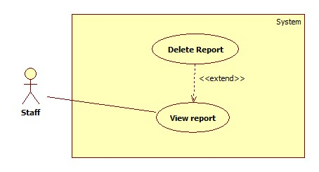

Figure 20: <Staff> Delete report

Use Case Specification

|  |  |  |  |
| --- | --- | --- | --- |
| **USE CASE – SU004** | | | |
| **Use Case No.** | SU004 | **Use Case Version** | 1.0 |
| **Use Case Name** | Delete Report | | |
| **Author** | Ho Dac Nghia | | |
| **Date** | 15/01/2014 | **Priority** | Normal |
| **Actor:** Staff  **Summary:**  Staff use this case to delete report.  **Goal:**  Allow staff to delete report.  **Triggers:**   * Click menu item "Quản lí phản hồi". * On the report list, click report item to view details of report. * Click "Xóa" to delete report. * Click “Đồng ý”.   **Preconditions:**   * Staff must log in the system. * There must be at least one report in the report list   **Post Conditions:**   * **Success:** The report of a traffic sign will be removed from server and database * **Fail:** No report removed   **Main Success Scenario:**   |  |  |  | | --- | --- | --- | | Step | Actor Action | System Response | | 1 | Click menu item “Quản lí phản hồi”.  [Alternative1] | Redirect to Report List Page, contains:  Table with 4 columns, record of 20 latest report:  - Mã số: label  - Tên người phản hồi: label  - Thời gian: label  - Nội dung: label  - Xem chi tiết: link | | 1 | [Alternative 1]  Click on the “Xóa” link | Show confirms windows with message:  “Bạn có muốn xóa phản hồi này.” | | 2 | Click “Đồng ý” button.  [Alternative 3] | The selected report will be removed from server.  An message is display: “Phản hồi đã được xóa”. |   **Alternative Scenario:**   |  |  |  | | --- | --- | --- | | No | Actor Action | System Response | | 1 | [Alternative 1]  Click on “xem chi tiết” link | Redirect to Report Detail Page, contains detail of User’s Report, include:  Mã số: label  -Tên người phản hồi: label  -Thời gian: label  -Nội dung: label  -Hình ảnh kết quả nhận diện: label  -Xóa: button | | 2 | Click on the “Xóa” button | Show confirms windows with message:  “Bạn có muốn xóa phản hồi này.” | | 3 | Click “Đồng ý” button.  [Alternative 3] | The selected report will be removed from server.  An message is display: “Phản hồi đã được xóa”. |  |  |  |  | | --- | --- | --- | | No | Actor Action | System Response | | 1 | [Alternative 3]  Click “Hủy” | System close message box. |   **Exceptions:** N/A **Relationships:** N/A  **Business Rules:** N/A | | | |

Table 21: <Staff> Delete report

##### <Staff, Admin> Active Account

Use Case Diagram

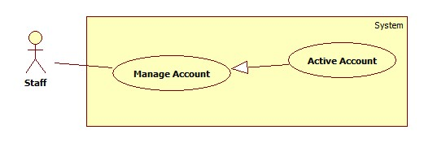

Figure 21: <Staff, Admin> Active Account

Use Case Specification

|  |  |  |  |
| --- | --- | --- | --- |
| **USE CASE – AD002** | | | |
| **Use Case No.** | AD002 | **Use Case Version** | 2.0 |
| **Use Case Name** | Active Account | | |
| **Author** | Tran Le Tuan | | |
| **Date** | 15/01/2014 | **Priority** | Normal |
| **Actor:** Admin  **Summary:**  This user case allow admin to active an accout  **Goal:**  A inactive account will be activated  **Triggers:**   * In our system, when we do not want an user to login, we inactive his/her account. We can active the inactivated account so they can login again. * To active an account, admin must: * From the admin Home Page, click the menu item “Account Manager”. * Check the Select checkbox of the account record, select “Active” on the drop down list, and press “Process” button.   **Preconditions:**   * User must logged in the system with the role is admin. * There must be at least 1 inactive account in database.   **Post Conditions:**   * **Success:** The selected account(s) will be activated. * **Fail:** No account activated.Transfer to error page.   **Main Success Scenario:**   |  |  |  | | --- | --- | --- | | Step | Actor Action | System Response | | 1 | Click menu item“Account Manager”. | Redirect to Account Manager Page, includes a panel with 2 tabs:   * Account List * Create Account   Current tab is Account List. This tab includes:   * Table with 4 column: * Account ID: label * Username: label * Email: label * Role: label * Action: dropdownlist, values: Inactive, Active. * Process: button | | 2 | Check the checkboxs of the account(s), select “Active” on the drop down list, and press “Process” button. | The selected account(s) will be activated  [Exception 1,2] |   **Alternative Scenario:** N/A  **Exceptions:**   |  |  |  | | --- | --- | --- | | No | Actor Action | System Response | | 1 | The account has already been activated by another admin | Nothing happen, the account(s) status is active | | 2 | Check no checkbox, press “Process” button | Display error message:  “Please select account to activated.” |   **Relationships:** Manage Account  **Business Rules:**   * Admin can’t active/inactive account of themselves or other admin. | | | |

Table 22: <Staff, Admin> Active Account

##### <Staff, Admin> Deactivate Account

Use Case Diagram

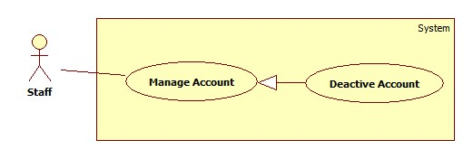

Figure 22: <Staff, Admin> Deactivate Account

Use Case Specification

|  |  |  |  |
| --- | --- | --- | --- |
| **USE CASE – AD003** | | | |
| **Use Case No.** | AD003 | **Use Case Version** | 2.0 |
| **Use Case Name** | Inactive Account | | |
| **Author** | Tran Le Tuan | | |
| **Date** | 15/01/2014 | **Priority** | Normal |
| **Actor:** Admin  **Summary:**  This user case allow admin to active an account  **Goal:**  A active account will be inactivated  **Triggers:**   * In our system, when we do not want an user to login, we inactive his/her account. The account can be activated later. * To active an account, admin must: * From the admin Home Page, click the menu item “Account Manager”. * Check the Select checkbox of the account record, select “Active” on the drop down list, and press “Process” button.   **Preconditions:**   * User must logged in the system with the role is admin * There must be at least 1 active account in database.   **Post Conditions:**   * **Success:** The selected account(s) will be inactivated. * **Fail:** No account inactivated.Transfer to error page.   **Main Success Scenario:**   |  |  |  | | --- | --- | --- | | Step | Actor Action | System Response | | 1 | Click menu item“Account Manager”. | Redirect to Account Manager Page, includes a panel with 2 tabs:   * Account List * Create Account   Current tab is Account List. This tab includes:   * Table with 5 column: * Account ID: label * Username: label * Email: label * Role: label * Action: dropdownlist, values: Inactive, Active. * Process: button | | 2 | Check the checkboxs of the account, select “Inactive” on the drop down list, and press “Process” button. | The selected account(s) will be inactivated.  [Exception 1,2] |   **Alternative Scenario:** N/A  **Exceptions:**   |  |  |  | | --- | --- | --- | | No | Actor Action | System Response | | 1 | The account has already been inactivated by another admin. | Nothing happen, the account(s) status is inactive | | 2 | Check no checkbox, press “Process” button. | Display error message:  “Please select account to deactivated.” |   **Relationships:** Manage Account  **Business Rules:**   * Admin can’t active/inactive account of themselves or other admin. | | | |

Table 23: <Staff, Admin> Deactivate Account

##### <Staff, Admin> Make statistic

Use Case Diagram

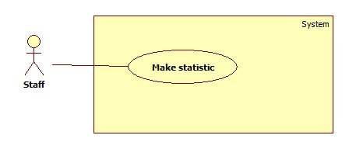

Figure 23: <Staff, Admin> Make statistic

Use Case Specification

|  |  |  |  |
| --- | --- | --- | --- |
| **Use Case Name** | Make Statistics | | |
| **Author** | Ho Dac Nghia | | |
| **Date** | 15/01/2014 | **Priority** | Normal |
| **Actor:** Staff  **Summary:**  This user case allow staff to make Statistics about User and Report.  **Goal:**   * Have Statistics information about user or report.   **Triggers:**   * Click menu item “Thống Kê” -> “Drop down list” have 2 item “Thống kê người dùng” and “Thống kê phản hồi” * Click on “Thống kê người dùng” -> Statistics info of User * Click on “Thống kê phản hồi” -> Statistics info of Report   **Preconditions:**   * User must logged in the system with the role is staff.   **Post Conditions:**   * **Success:** Statistics info of User or Report were displayed. * **Fail:** No statistics info displayed.   **Main Success Scenario:**   |  |  |  | | --- | --- | --- | | Step | Actor Action | System Response | | 1 | Click menu item“Thống Kê”  [Alternative 1] | Dropdown list, contains :   * Thống kê người dùng * Thống kê phản hồi | | 2 | Click on “Thống kê người dùng” button | Redirect to Statistics Detail Page, contains detail of User’s Statistics | | 3 | Click on “Thống kê phản hồi” button | Redirect to Statistics Detail Page, contains detail of Report’s Statistics |   **Exceptions:** N/A  **Relationships:** Make Statistics  **Business Rules:** N/A | | | |

Table 24: <Staff, Admin> Make statistic

#### <Admin> Admin overview

Use Case Diagram

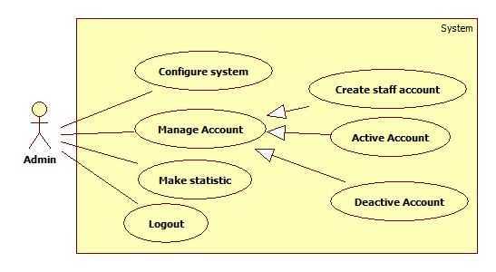

Figure 24: <Admin> Admin overview

##### <Admin> Configure system

Use Case Diagram

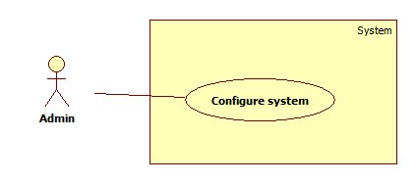

Figure 25: <Admin> Configure system

Use Case Specification

Table 25: <Admin> Configure system

##### <Admin> Create staff account

Use Case Diagram

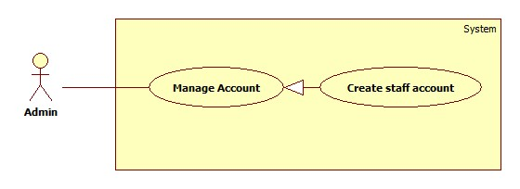

Figure 26: <Admin> Create staff account

Use Case Specification

|  |  |  |  |
| --- | --- | --- | --- |
| **USE CASE – AD001** | | | |
| **Use Case No.** | AD001 | **Use Case Version** | 2.0 |
| **Use Case Name** | Create Staff Account | | |
| **Author** | Tran Le Tuan | | |
| **Date** | 15/01/2014 | **Priority** | Normal |
| **Actor:** Admin  **Summary:**  Admin use this case to create account for staff.  **Goal:**  A new account staff will be added to database  **Triggers:**   * In our system, the account of a staff will be added only by admin. * To create a new account, admin must: * From the admin Home Page, click the menu item “Quản lí tài khoản”. * In the Account Manager Page, click on the Tab “Tạo tài khoản”. * Input new account information, click “Đồng ý” to finish.   **Preconditions:**   * Admin must login system.   **Post Conditions:**   * **Success:** A new account will be created. The account will be displayed on account list. * **Fail:** No account created.Transfer to error page or still in current page.   **Main Success Scenario:**   |  |  |  | | --- | --- | --- | | Step | Actor Action | System Response | | 1 | Click menu item “Quản lí tài khoản”. | Redirect to Account Manager Page, includes a panel with 2 tabs:   * Danh sách tài khoản * Tạo tài khoản   Current tab is Account List. This tab includes:   * Table with 5 column: * Mã số: label * Tên: label * Email: label * Chức vụ: label * Tình trạng: checkbox * Action: dropdownlist, values: Khóa, Đã kích hoạt. * Đồng ý: button | | 2 | Click Tab “Tạo tài khoản”. | Display a tab panel includes:   * Tên Tài Khoản: textbox (min length, max length: 30, required). * Mật mã: textbox (password box, min length, max length: 30, required). * Chức vụ : dropdownlist, values: Nhân viên, Thành viên. * Đồng ý: button * Hủy: button | | 3 | Input new account information.  Click “Đồng ý” button.  [Alternative 1] | System will add the account to database.  Show the tab panel “Danh sách tài khoản”  [Exception 1,2,3,4] |   **Alternative Scenario:**   |  |  |  | | --- | --- | --- | | No | Actor Action | System Response | | 1 | Click on “hủy” button | The form is emptied. |   **Exceptions:**   |  |  |  | | --- | --- | --- | | No | Actor Action | System Response | | 1 | Not enter enough require information. | Display error message: “Thông tin khai báo chưa đầy đủ.” | | 2 | Username/password is not in range [6,30] | Display error message: “Tên tài khoản/Mật mã phải từ 6 đến 30 kí tự” | | 3 | Confirm password is not equal password | Display error message:  “Mật mã nhập lại không trùng khớp.” | | 4 | Username or email existed in database | Display error message:  “Tài khoản hoặc Email đã tồn tại.” |   **Relationships:** Manage Account  **Business Rules:**   * Each account is active when added to database. * The “Nhập lại mật khẩu” value must match “Mật khẩu” value. | | | |

Table 26: <Admin> Create staff account

## Software System Attribute

### Usability

#### Graphic User Interface

* All the text, label and image in staff, instructor and student page should be English.
* All the text, label and image in admin page should be English.

#### Usability

* Website admin, staff and instructor should need more than one week of training to be productive with the system.
* The student can use the system easily without training.

#### Installation

* The system must be easy to deploy. Customer can deploy successfully and learn to configure, maintain the system within one day of training.
* The mobile app must be easy to install. Compatible with almost Android Phone.
* The attached manual guide must be clear. User can read and do themselves without developer’s help.

### Reliability

* N/A

### Availability

* N/A

### Security

* Privacy: Each role of user has a specific permission to interact with system.
* System always checks authorization and authenticated before doing anything.
* Only admin can grant permission to staff.

### Maintainability

* N/A

### Portability

* N/A

### Performance

* Detect Faces From an Image: 3~4 seconds/image.
* Recognize Faces: 20~30 seconds/100 faces. With training set of 30 students, 600 images.
* The image upload speed depend on the speed of the network.

## ERD

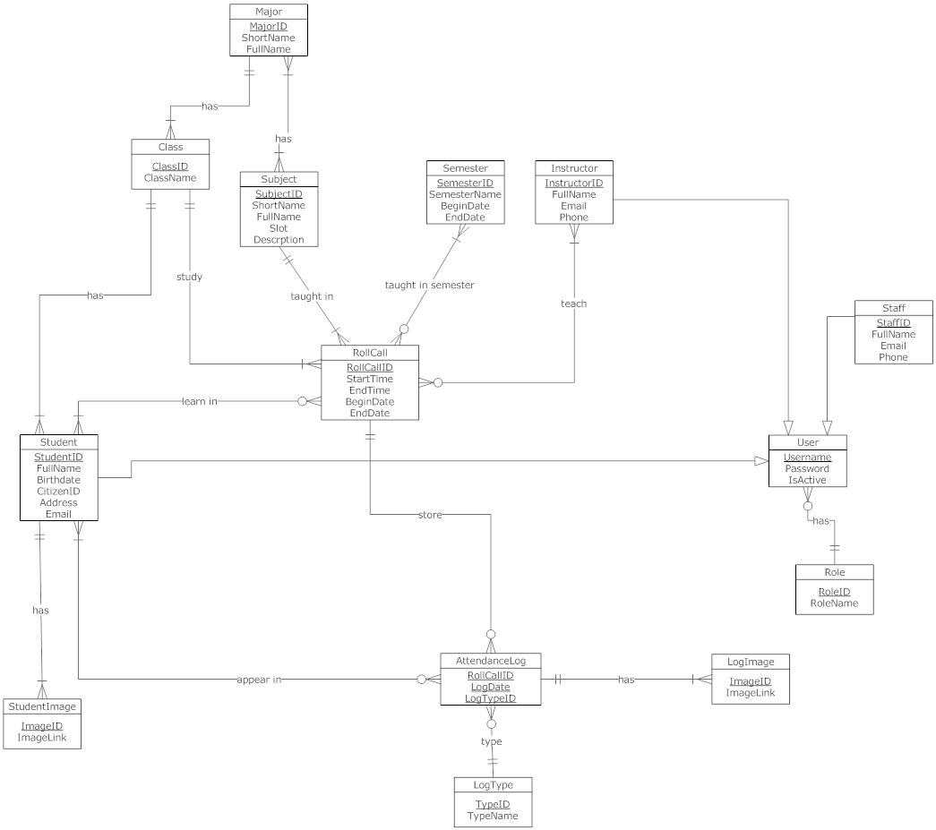

Figure 27: ERD - Conceptual Diagram